John-Joshua Izuegbu

Professor Zhang

CIS 3355

November 18, 2020

1. **At a terminal window of an openSUSE VM where you have an active web server and you are elevated to root privileges**, type the command as shown to verify that the Apache web server is up and running
   1. 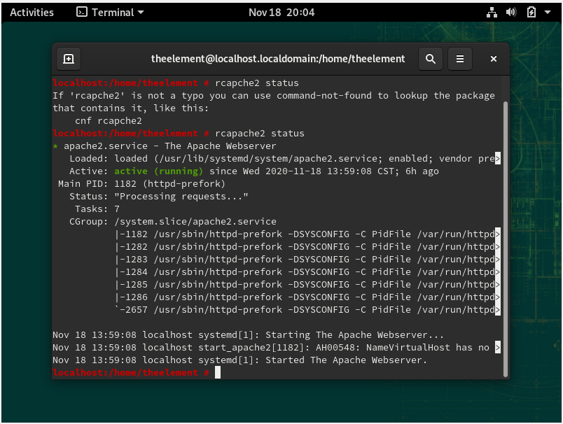
   2. 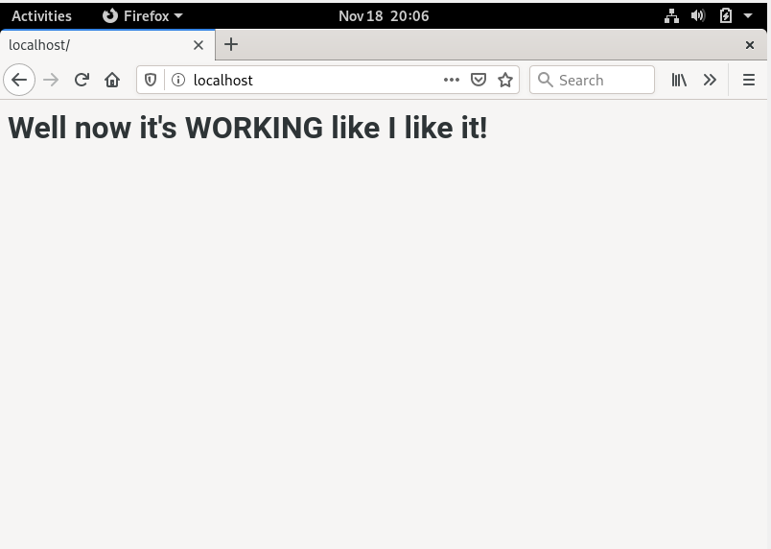
2. **Type the command shown to open YaST**,**Check the Server Modules installed to make certain php is installed and enabled.**
   1. 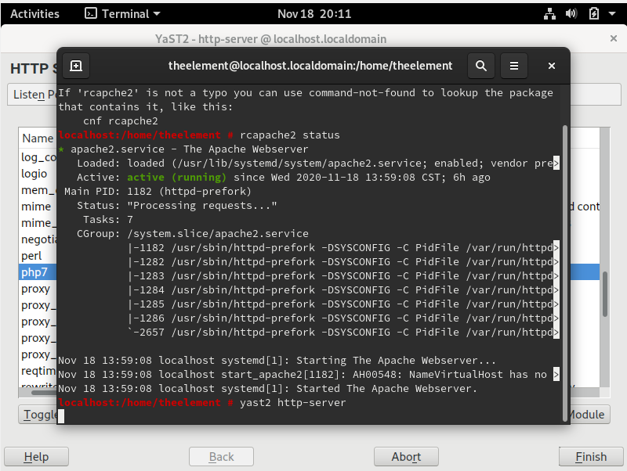
   2. 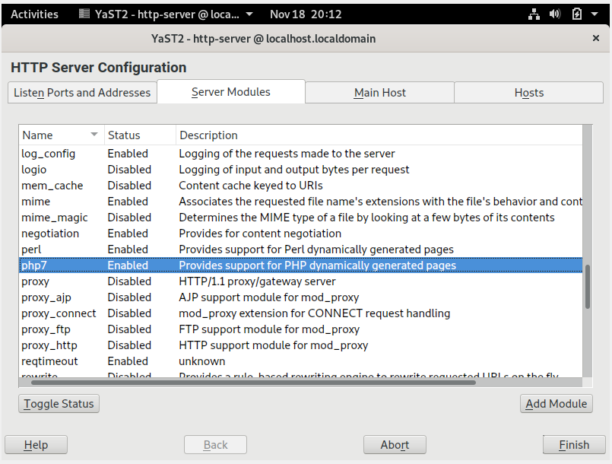
3. **Type the commands shown to:** Change to the Web server’s root directory, See what files are in it, Create a new file named testphp_yourusername.php in that directory.
   1. 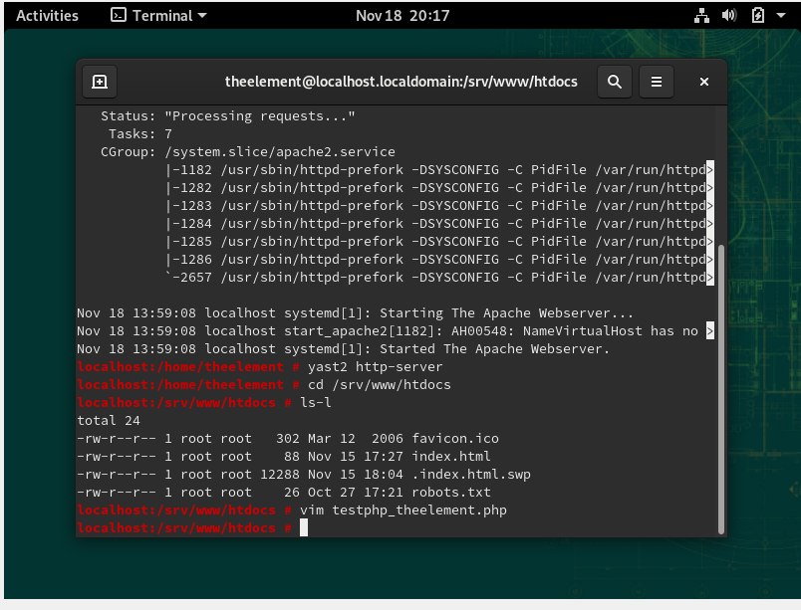
4. **Type the Code Shown to Create a PHP Application:** Replace Professor Miertschin and Prof. M with your name, Save the file in the working directory (which should be /srv/www/htdocs).
   1. 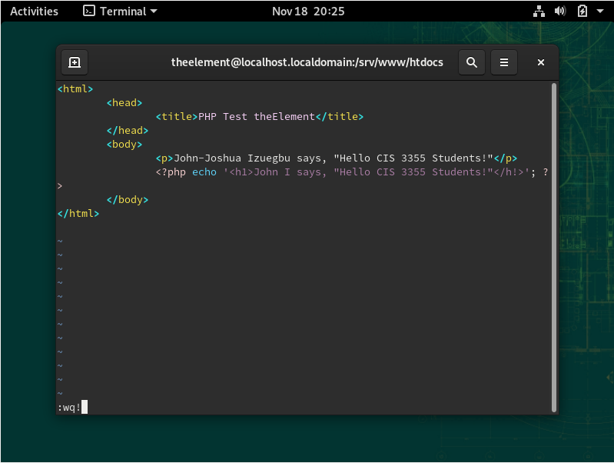
5. **Check the Application by Requesting the Page from Your Web Server:** The request for the page goes to localhost.
   1. 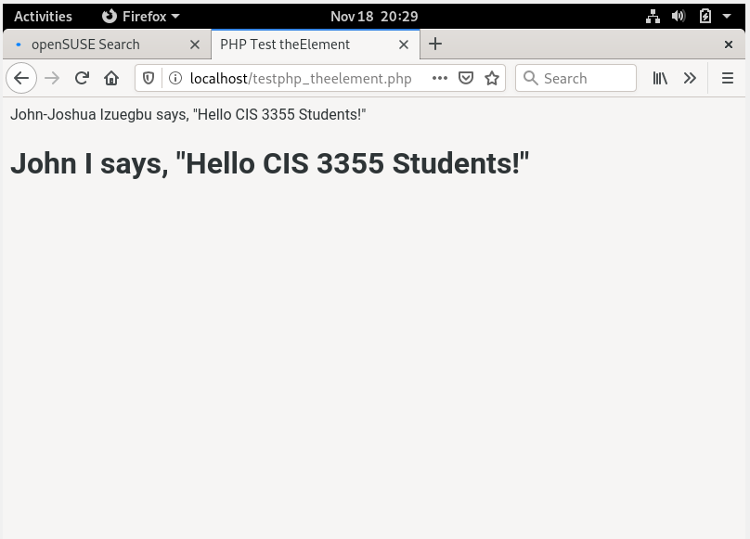
6. **Add a PHP Built‐in Function Call: Add one line of code as shown** -The built-in PHP function phpinfo returns information about the version of php running on the web server. Save the file
   1. 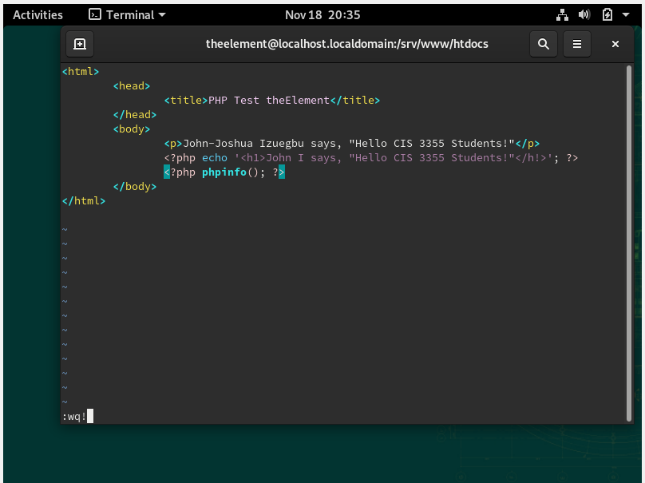
7. **Request the Page Again**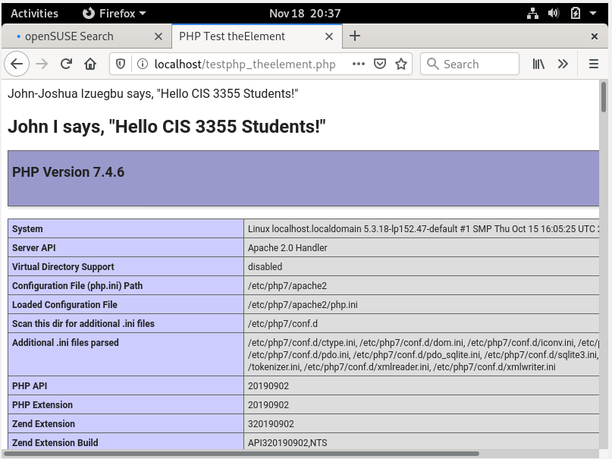
8. **Use YaSTto Install the PHP7‐SOAP Module:** Type yast2, Select the Software Manager module1. Search for php7-soap2. Select the php7-soap package for installation. Click on the Accept button. Wait for the install to complete. Click Finish . Restart the Apache server
   1. 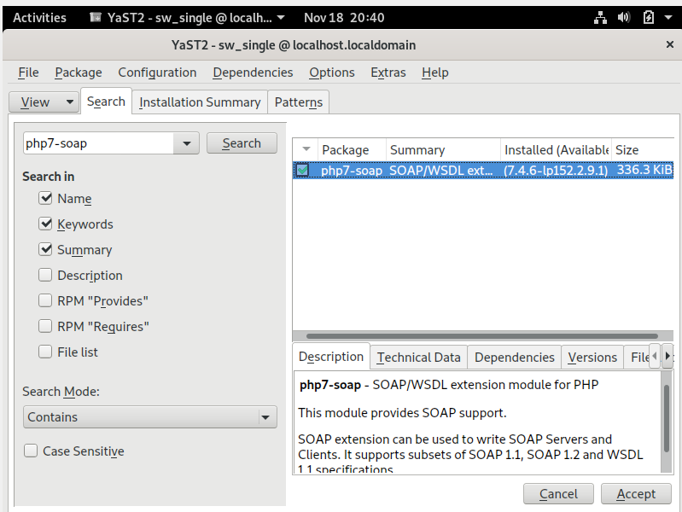
   2. 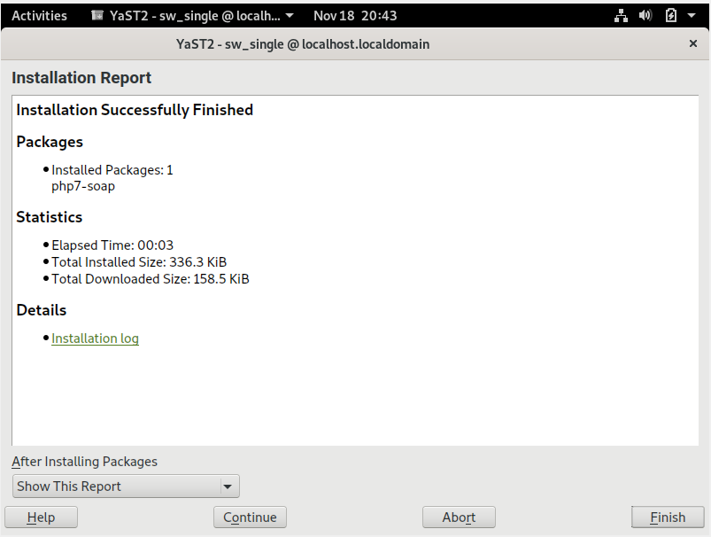
   3. 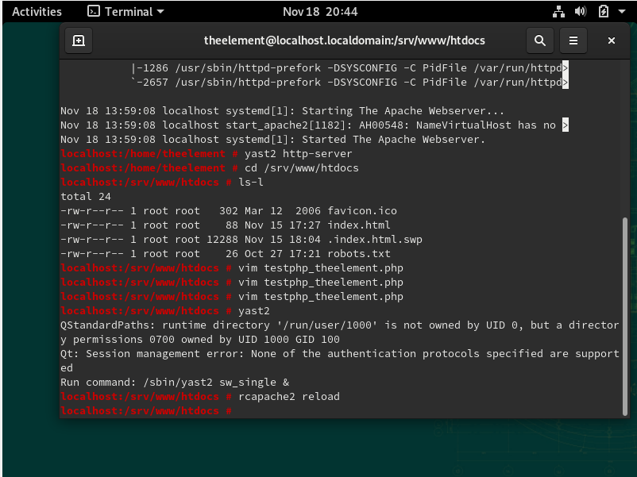
9. **Use vim to create the file that consumes the stockquote web service by using its GetQuote function to retrieve a stock price**. Customize the contents to include your name. The file, when complete, should be placed in the DocumentRoot directory of your web server running in your VM, which, by default, is set to /srv/www/htdocs.
   1. 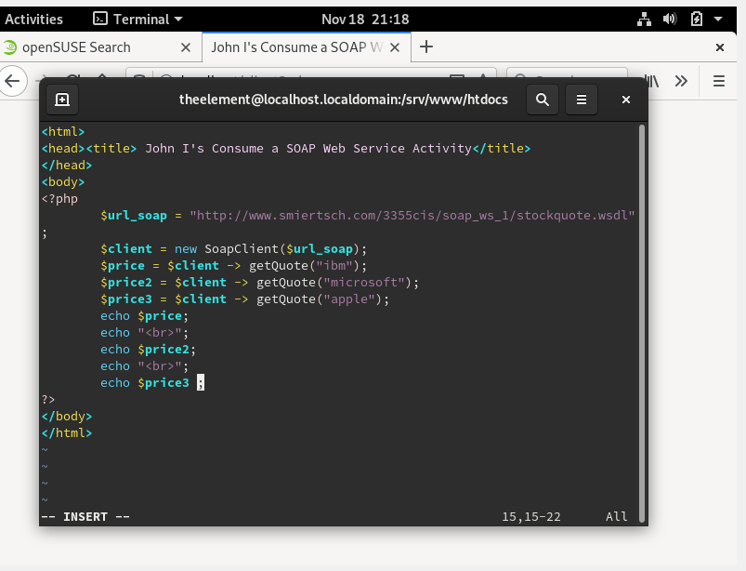
   2. 